ListIterator->

1.to overcome limits of enumeration and iterator.

//its bidirectional..

2.read,remove,*replacement,*addition of new objects.

Create listIterator->

Public ListIterator listIterator()->list

Ex-> ListIterator itr=l listIterator();

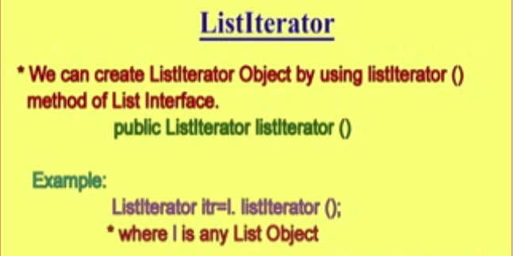

ListIterator is child class of Iterator->

**Methods->**

